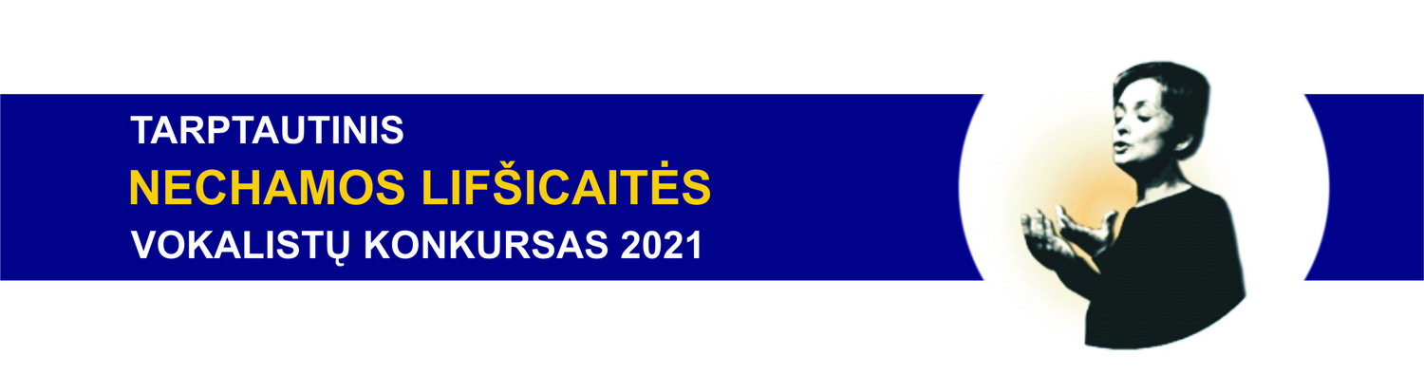
REGISTRATION FORM

Please send the completed registration form together with the photo, music sheet and payment copy by e-mail nechama@competition.lt until 2021.08.01

*Required fields

Participant‘s Name and Surname *
Date of birth *
Represented country and address*
Contact person*
Contact person‘s e-mail address*
Contact person‘s tel. nr.*
List of songs ( authors, title, duration, language)*
Short creative biography, indicating the name of the singing teacher

Accomodation information:
Dates (arrival- departure)

Need a guest house, number of people
Need a hotel, number of people

I agree with the terms and conditions
of the competition*
(markX)
I agree, that mypersonal information,
such as name, photo, creative biography, and program may be published online, in the competition catalog, and in other sources.
See: Privacy Data policy*
(mark X)

Registration fee and details:
The registration fee is EUR 30 for Group A and B participants and EUR 50 for Group C participants.
Name: Tarptautinio Nechamos Lifsicaites vokalistu konkurso paramos fondas
Address: Vytauto g.25, LT-08119 Vilnius
Bank: AB SEB Bank
Swift: CBVILT2X
IBAN: LT897044090100884848;
Purpose of payment: participant’s Name, Surname registration fee

